

UNIVERSITY OF ENGINEERING AND TECHNOLOGY (UET), LAHORE
Department of Computer Science

Project Title:
PAW-SOME PETS & CO.
A Digital Management & Adoption Ecosystem
Submitted By: Muhammad Uzair
Roll Number: 2026(S)-CS-96
Teacher Name: Ms. Aliya Farooq
Subject: AICT
University: UET Lahore
Language: C++
Project Type: Console Based Application

INTRODUCTION & PROJECT SCOPE

Project Introduction
"Paw-Some Pets & Co." is a custom-built Command Line Interface (CLI) application developed to solve the logistical challenges of modern animal shelters. The system bridges the gap between shelter administrators, community donors, and potential pet adopters by centralizing data management into a single, cohesive platform.

Problem Statement
Manual record-keeping in animal shelters often leads to data fragmentation, loss of financial transparency, and difficulty in matching pets with the right owners. This project automates these processes to ensure every pet's health, history, and adoption status are tracked with 100% accuracy.

3. Project Objectives
- To implement a secure, multi-role access system.
- To utilize efficient data structures (Parallel Arrays) for high-speed data retrieval.
- To provide real-time financial auditing through a Transaction History log.
- To ensure a user-friendly experience through a consistent and aesthetic CLI design.

1. Functional Requirements

1.1 System Overview
The "Paw-Some Pets & Co." application is a comprehensive Pet Management and Adoption System designed to streamline shelter operations. It supports three distinct user roles: Administrative Staff, Pet Donors, and Customers/Adopters.

1.2 Administrative Requirements
The Admin module serves as the core management hub, requiring a secure password for access.
Inventory Management: Admin can view the full list of pets and update specific details (Name, Age, Health, etc.) for any record.
Data Organization: Ability to sort pets by age in both ascending and descending order using the Bubble Sort algorithm.
Record Maintenance: Admin can manually delete records or manage shelter capacity.
Financial Auditing: Access to separate "Donation Bank" and "Adoption Revenue" trackers to monitor shelter funds.
Business History: A transaction log that retains the last 10 financial events for auditing purposes.

1.3 Pet Donor Requirements
The Donor module allows members of the public to contribute to the shelter's mission.
Pet Intake: Users can register a new pet into the system by providing Name, Type, Breed, Age, Health status, and personality traits.
Financial Support: Donors can contribute any amount of money to the general shelter fund.
Capacity Awareness: Donors can check if the shelter has space available before attempting to donate a pet.

1.4 Customer / Adopter Requirements
The Customer module focuses on matching pets with new homes.
Pet Discovery: Users can browse the entire inventory or search for a specific pet by name using a case-insensitive search engine.
Adoption Process: Customers can select a pet for adoption, which triggers a fixed adoption fee (1000 PKR).
Automated Inventory Update: Upon successful adoption, the system automatically removes the pet from the active inventory and logs the transaction.

3. Data Structures Used
Variable / Structure | Data Type | Purpose
petNames[], petTypes[], petBreeds[], petAges[], petHealth[], petTraits[] | string[], int[], float[] | Parallel arrays storing all pet records (name, type, breed, age, health, traits)
petCount | int | Tracks number of pets currently in the shelter
donatedMoney, totalAdoptedMoney, fixFeeForAdoption | double | Financial tracking: donation bank, adoption revenue, and fixed adoption fee (PKR)
historyType[], historyAmount[], historyDetail[] | string[], double[], string[] | Parallel arrays storing up to 10 recent financial transaction records
adminUsername, adminPassword, eraseSpecialKey | string | Credential variables for admin login and factory reset; saved/loaded via file handling
ofstream / ifstream | File stream (from <fstream>) | Used to write (ofstream) and read (ifstream) data to/from pets.txt, finance.txt, history.txt, Credentials.txt
loops / Conditions / functions() | for/while / if/else / void & bool | Control flow (loops, decisions) and modular task functions used throughout the program

4. Program Structure / Wireframe

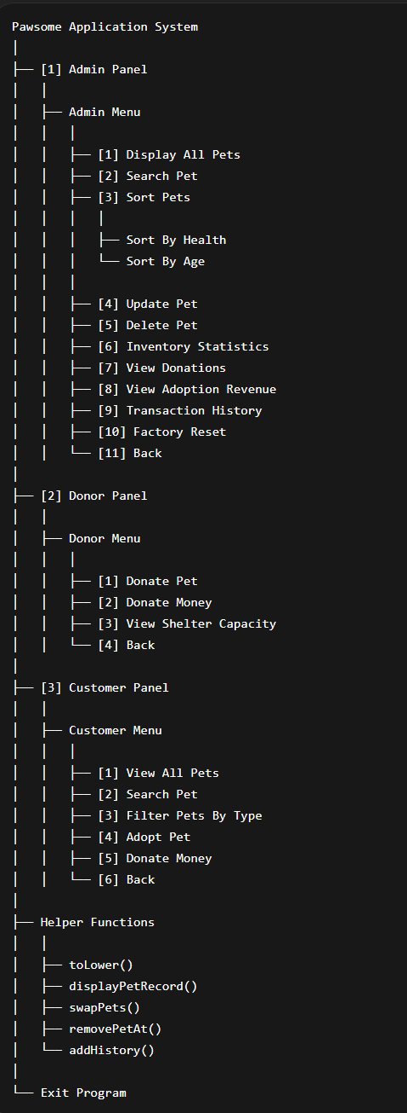

5. Console Output Screenshots

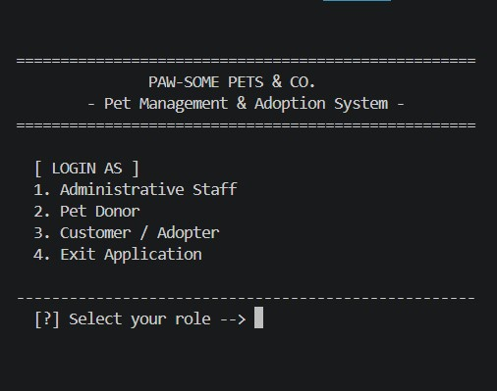

Figure 1: Role-selection gateway with unified branding header

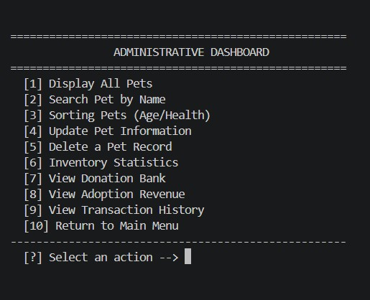

Figure 2: Administrative control panel with bracketed navigation
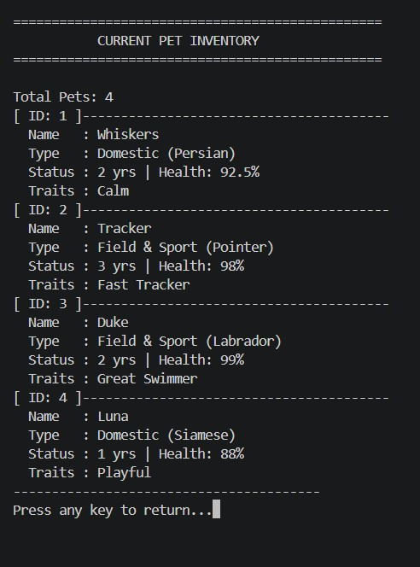
Figure 3: "Card Style" pet profiles showing vertical alignment of pet attributes
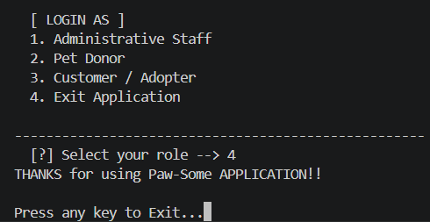

Figure 4: Showing exit screen

6. Complete Source Code
#include <iostream>
#include <fstream>
#include <conio.h>
using namespace std;

// GLOBAL DATA ARRAYS
const int max_capacity = 1000;

string petNames[max_capacity] = {"Whiskers", "Tracker", "Duke", "Luna"};
string petTypes[max_capacity] = {"Domestic", "Field & Sport", "Field & Sport", "Domestic"};
string petBreeds[max_capacity] = {"Persian", "Pointer", "Labrador", "Siamese"};
int petAges[max_capacity] = {2, 3, 2, 1};
float petHealth[max_capacity] = {92.5, 98.0, 99.0, 88.0};
string petTraits[max_capacity] = {"Calm", "Fast Tracker", "Great Swimmer", "Playful"};

double donatedMoney = 100;
double totalAdoptedMoney = 500;
double fixFeeForAdoption = 1000;

// Transaction history arrays
const int history_size = 10;
string historyType[history_size];
double historyAmount[history_size];
string historyDetail[history_size];
int historyCount = 0;

int petCount = 4;

// Important Credentials
string adminUsername = "admin";
string adminPassword = "123";
string eraseSpecialKey = "1A2B3C";

// Convert string to lowercase
// Manual ASCII lowercase conversion (using this method for case-insensitive search)
string toLower(string str)
{
for (int j = 0; j < str.length(); j++)
{
if (str[j] >= 65 && str[j] <= 90) // if capital
str[j] = str[j] + 32; // making it lowercase by adding 32
}
return str;
}

// Display a single pet record
void displayPetRecord(int i)
{
cout << "[ ID: " << i + 1 << " ]--------------------------------" << endl;
cout << " Name : " << petNames[i] << endl;
cout << " Type : " << petTypes[i] << " (" << petBreeds[i] << ")" << endl;
cout << " Status : " << petAges[i] << " yrs | Health: " << petHealth[i] << "%" << endl;
cout << " Traits : " << petTraits[i] << endl;
}

// Swap two pets in all arrays
// Swaps all parallel array data at positions j and j+1
void swapPets(int j)
{
float tempHealth = petHealth[j];
petHealth[j] = petHealth[j + 1];
petHealth[j + 1] = tempHealth;
string tempName = petNames[j];
petNames[j] = petNames[j + 1];
petNames[j + 1] = tempName;
string tempType = petTypes[j];
petTypes[j] = petTypes[j + 1];
petTypes[j + 1] = tempType;
string tempBreed = petBreeds[j];
petBreeds[j] = petBreeds[j + 1];
petBreeds[j + 1] = tempBreed;
int tempAge = petAges[j];
petAges[j] = petAges[j + 1];
petAges[j + 1] = tempAge;
string tempTrait = petTraits[j];
petTraits[j] = petTraits[j + 1];
petTraits[j + 1] = tempTrait;
}

// Remove pet at a given index
// Shifts all entries left to fill the gap then decrements petCount. Proper Deletion
void removePetAt(int found_index)
{
for (int i = found_index; i < petCount - 1; i++)
{
petNames[i] = petNames[i + 1];
petTypes[i] = petTypes[i + 1];
petBreeds[i] = petBreeds[i + 1];
petAges[i] = petAges[i + 1];
petHealth[i] = petHealth[i + 1];
petTraits[i] = petTraits[i + 1];
}
petCount--;
}

// Add transaction to history
void addHistory(string type, double amount, string detail)
{
if (historyCount < history_size)
{
historyType[historyCount] = type;
historyAmount[historyCount] = amount;
historyDetail[historyCount] = detail;
historyCount++;
}
}

// Save all pet data to file
void savePetsToFile()
{
ofstream petFile("pets.txt");
petFile << petCount << "\n";
for (int i = 0; i < petCount; i++)
{
petFile << petNames[i] << "\n";
petFile << petTypes[i] << "\n";
petFile << petBreeds[i] << "\n";
petFile << petAges[i] << "\n";
petFile << petHealth[i] << "\n";
petFile << petTraits[i] << "\n";
}
petFile.close();
}

// Load all pet data from file
void loadPetsFromFile()
{
ifstream petFile("pets.txt");
if (!petFile)
return;
petFile >> petCount;
petFile.ignore();
for (int i = 0; i < petCount; i++)
{
getline(petFile, petNames[i]);
getline(petFile, petTypes[i]);
getline(petFile, petBreeds[i]);
petFile >> petAges[i];
petFile >> petHealth[i];
petFile.ignore();
getline(petFile, petTraits[i]);
}
petFile.close();
}

// Save financial data to file
void saveFinanceToFile()
{
ofstream finFile("finance.txt");
finFile << donatedMoney << "\n";
finFile << totalAdoptedMoney << "\n";
finFile << fixFeeForAdoption << "\n";
finFile.close();
}

// Load financial data from file
void loadFinanceFromFile()
{
ifstream finFile("finance.txt");
if (!finFile)
return;
finFile >> donatedMoney;
finFile >> totalAdoptedMoney;
finFile >> fixFeeForAdoption;
finFile.close();
}

// Save transaction history to file
void saveHistoryToFile()
{
ofstream hisFile("history.txt");
hisFile << historyCount << "\n";
for (int i = 0; i < historyCount; i++)
{
hisFile << historyType[i] << "\n";
hisFile << historyAmount[i] << "\n";
hisFile << historyDetail[i] << "\n";
}
hisFile.close();
}

// Load transaction history from file
void loadHistoryFromFile()
{
ifstream hisFile("history.txt");
if (!hisFile)
return;
hisFile >> historyCount;
hisFile.ignore();
for (int i = 0; i < historyCount; i++)
{
getline(hisFile, historyType[i]);
hisFile >> historyAmount[i];
hisFile.ignore();
getline(hisFile, historyDetail[i]);
}
hisFile.close();
}
// Saving Credentials
void savingCredentials()
{
ofstream credFile("Credentials.txt");
credFile << adminUsername << "\n";
credFile << adminPassword << "\n";
credFile << eraseSpecialKey << "\n";
credFile.close();
}
// Loading Credentials
void loadingCredentials()
{
ifstream credFile("Credentials.txt");
if (!credFile)
return;
getline(credFile, adminUsername);
getline(credFile, adminPassword);
getline(credFile, eraseSpecialKey);
credFile.close();
}

// Saving all data
void saveAllData()
{
savePetsToFile();
saveFinanceToFile();
saveHistoryToFile();
savingCredentials();
}

// Loading all data
void loadAllData()
{
loadPetsFromFile();
loadFinanceFromFile();
loadHistoryFromFile();
loadingCredentials();
}

// Admin menu: Display all pets
void adminDisplayAllPets()
{
system("cls");
cout << "================================================" << endl;
cout << " CURRENT PET INVENTORY " << endl;
cout << "================================================" << endl;
cout << "\nTotal Pets: " << petCount << endl;

for (int i = 0; i < petCount; i++)
{
cout << "[ ID: " << i + 1 << " ]----------------------------------------" << endl;
cout << " Name : " << petNames[i] << endl;
cout << " Type : " << petTypes[i] << " (" << petBreeds[i] << ")" << endl;
cout << " Status : " << petAges[i] << " yrs | Health: " << petHealth[i] << "%" << endl;
cout << " Traits : " << petTraits[i] << endl;
}
cout << "----------------------------------------" << endl;
cout << "Press any key to return...";
getch();
system("cls");
}

// Admin menu: Search pet by name
void adminSearchPet()
{
while (true)
{
system("cls");
string searchmenuoption;
cout << "=====================================\n";
cout << " Searching Pets \n";
cout << "=====================================\n\n";
cout << "---> 1.Search\n";
cout << "---> 2.Go back\n";
cout << " Enter you choice : ";
cin >> searchmenuoption;

if (searchmenuoption == "1")
{
system("cls");
cout << "Enter the name you want to search: ";
string searchName;
cin.ignore();
getline(cin, searchName);

bool isFound = false;
for (int i = 0; i < petCount; i++)
{
if (toLower(petNames[i]) == toLower(searchName)) // using tolower function i made to search with case insenstiveness
{
displayPetRecord(i);
isFound = true;
cout << "\nPress any key to go back...";
getch();
break;
}
}
if (!isFound)
{
cout << "No record Found for : " << searchName << endl;
cout << "Press any key to go back...";
getch();
}
}
else if (searchmenuoption == "2")
{
break;
}
else
{
cout << "Wrong selection!\n";
cout << "Press any key to continue...";
getch();
}
}
}

// Admin menu: Sort pets by health (bubble sort, highest first)
void sortByHealth()
{
for (int i = 0; i < petCount - 1; i++)
for (int j = 0; j < petCount - i - 1; j++)
if (petHealth[j] < petHealth[j + 1])
swapPets(j);

cout << "Successfully sorted All by health! Use Display All to check..." << endl;
cout << "\nPress any key to continue...";
getch();
}

// Admin menu: Sort pets by age (bubble sort, oldest or youngest first)
void sortByAge()
{
int sortageOptions;
system("cls");
// Menu for age sort methods
cout << "---> 1. Oldest to Youngest\n";
cout << "---> 2. Youngest to Oldest\n";
cout << " Enter your selection : ";
cin >> sortageOptions;

if (sortageOptions == 1)
{
for (int i = 0; i < petCount - 1; i++)
for (int j = 0; j < petCount - i - 1; j++)
if (petAges[j] < petAges[j + 1])
swapPets(j);

cout << "Successfully sorted All by age(Oldest to Youngest) !!\n Use Display All to check..." << endl;
}
else if (sortageOptions == 2)
{
for (int i = 0; i < petCount - 1; i++)
for (int j = 0; j < petCount - i - 1; j++)
if (petAges[j] > petAges[j + 1])
swapPets(j);

cout << "Successfully sorted All by age(Youngest to oldest) !!\n Use Display All to check..." << endl;
}
cout << "\nPress any key to continue...";
getch();
}

// Admin menu: Sorting menu (health or age)
void adminSortMenu()
{
while (true)
{
system("cls");
int sortOptions;
cout << "========================================\n";
cout << " Sorting of Pets \n";
cout << "========================================\n";
cout << "---> 1.Sort by Health?(highest first) \n";
cout << "---> 2.Sort by Age?\n";
cout << "---> 3.Go Back\n";
cout << "\nEnter you selection : ";
cin >> sortOptions;

if (sortOptions == 1)
{
sortByHealth();
}
else if (sortOptions == 2)
{
sortByAge();
}
else if (sortOptions == 3)
{
break;
}
else
{
cout << "Wrong Selection! Enter again! \n";
cout << "Press any key to continue...";
getch();
}
}
}

// Admin menu: Update pet information
void adminUpdatePet()
{
system("cls");
cout << "=====================================\n";
cout << " Updating Pets \n";
cout << "=====================================\n\n";
cout << "Enter the name you want to update: ";
string updateName;
cin.ignore();
getline(cin, updateName);

bool isFound = false;
for (int i = 0; i < petCount; i++)
{
if (toLower(petNames[i]) == toLower(updateName))
{
// showing old record first
cout << "OLD Record of " << updateName;
displayPetRecord(i);
isFound = true;
cout << "\n Press any key to continue...";
getch();
system("cls");

// getting new data from user and replacing it with new
cout << "=====================================\n";
cout << " Updating Pets \n";
cout << "=====================================\n\n";
cout << "Enter the new name for updating : ";
string tempPetname;
getline(cin, tempPetname);
cout << "Enter the new type for updating : ";
string tempPettype;
getline(cin, tempPettype);
cout << "Enter the new pet breed for updating : ";
string tempPetbreeds;
getline(cin, tempPetbreeds);
cout << "Enter the new pet age for updating : ";
int tempPetage;
cin >> tempPetage;
while (tempPetage <= 0 || tempPetage > 30)
{
cout << "Invalid! Age must be between 1 and 30 : ";
cin >> tempPetage;
}
cin.ignore();
cout << "Enter the new pet health for updating : ";
double tempPethealth;
cin >> tempPethealth;
while (tempPethealth < 0 || tempPethealth > 100)
{
cout << "Invalid! Health must be between 0 and 100 : ";
cin >> tempPethealth;
}
cin.ignore();
cout << "Enter the new trait of the pet for updating : ";
string tempPettrait;
getline(cin, tempPettrait);

// storing updated data back to arrays
petNames[i] = tempPetname;
petTypes[i] = tempPettype;
petBreeds[i] = tempPetbreeds;
petAges[i] = tempPetage;
petHealth[i] = tempPethealth;
petTraits[i] = tempPettrait;

saveAllData();
cout << "Successfully updated the Data... Check 'search by name' or 'display all' to confirm";
break;
}
}
if (!isFound)
cout << "No record Found for : " << updateName << endl;

cout << "\nPress any key to return to Admin Menu...";
getch();
system("cls");
}

// Admin menu: Delete a pet record
void adminDeletePet()
{
system("cls");
cout << "=====================================\n";
cout << " Removing Pets \n";
cout << "=====================================\n\n";
cout << "Enter the pet name you want to delete: ";
string deleteName;
cin.ignore();
getline(cin, deleteName);

bool isFound = false;
int found_index = -1;

for (int i = 0; i < petCount; i++)
{
if (toLower(petNames[i]) == toLower(deleteName))
{
cout << " Record of " << deleteName << endl;
displayPetRecord(i);
isFound = true;
found_index = i;
cout << "press any key to continue...";
getch();
system("cls");

// remove pet from arrays proper deletion meaning shifting the elements from right side
removePetAt(found_index);

saveAllData();
cout << "=====================================\n";
cout << " Removing Pets \n";
cout << "=====================================\n\n";
cout << "Succesfully Deleted Record of " << deleteName;
break;
}
}
if (!isFound)
cout << "No record Found for : " << deleteName << endl;

cout << "\nPress any key to return to Admin Menu...";
getch();
system("cls");
}

// Admin menu: inventory statistics
void adminInventoryStats()
{
system("cls");
while (true)
{
if (petCount == 0)
{
cout << "Inventory is empty!";
break;
}
else
{
int domesticCount = 0, fieldsportCount = 0;
int oldidx = 0, youngidx = 0;

// count domestic and field & sport pets
for (int i = 0; i < petCount; i++)
{
if (petTypes[i] == "Domestic" || petTypes[i] == "domestic")
domesticCount++;
if (petTypes[i] == "Field & Sport" || petTypes[i] == "Field and Sport")
fieldsportCount++;
}

// find oldest and youngest pets
for (int i = 0; i < petCount; i++)
{
if (petAges[i] > petAges[oldidx])
oldidx = i;
if (petAges[i] < petAges[youngidx])
youngidx = i;
}

// display statistics
cout << "=======================================\n";
cout << " Inventory Statistics \n";
cout << "=======================================\n\n";
cout << " ---> Domestic pets : " << domesticCount << "\n";
cout << " ---> Field & Sport pets : " << fieldsportCount << "\n";
cout << " ---> Oldest pet : " << petNames[oldidx] << "\n";
cout << " ---> Youngest pet : " << petNames[youngidx] << "\n\n";
cout << "=======================================\n\n";
cout << " Press any key to go back..." << endl;
getch();
break;
}
}
}

// Admin menu: view donation bank balance
void adminViewDonations()
{
system("cls");
cout << "=============================================\n";
cout << " Donation Money \n";
cout << "=============================================\n";
cout << " Donation Bank Balance : " << donatedMoney << " PKR";
cout << "\nPress any key to go back...";
getch();
}

// Admin menu: view adoption revenue
void adminViewAdoptionRevenue()
{
system("cls");
cout << "=============================================\n";
cout << " Adoption Fee Money \n";
cout << "=============================================\n";
cout << " Adoption Fee Bank Balance : " << totalAdoptedMoney << " PKR";
cout << "\nPress any key to go back...";
getch();
}

// Admin menu: view transaction history
void adminViewTransactionHistory()
{
system("cls");
cout << "================================================" << endl;
cout << " RECENT TRANSACTION HISTORY " << endl;
cout << "================================================" << endl;

if (historyCount == 0)
{
cout << "\n No transactions recorded yet." << endl;
}
else
{
for (int i = 0; i < historyCount; i++)
{
cout << i + 1 << ". [" << historyType[i] << "]" << endl;
cout << " Amount : " << historyAmount[i] << " PKR" << endl;
cout << " Details: " << historyDetail[i] << endl;
cout << "----------------------------------------------------" << endl;
}
}
cout << "\nPress any key to return...";
getch();
}

// Admin menu: factory reset (clear all data)
void adminFactoryReset()
{
while (true)
{
system("cls");
string confirmationMsg;
cout << "=======================================\n";
cout << " FACTORY RESET \n";
cout << "=======================================\n\n";
cout << "[1] Are you sure you want to erase all data?(yes/no) : " << endl;
cout << "[2] Go back" << endl
<< endl;
cout << "---------------------------------------\n";
cout << "[?] Select an action -->(yes/no for [1] or '2' for [2]) : ";
cin >> confirmationMsg;

if (confirmationMsg == "yes")
{
string tempSpecialKey;
cout << "Please Enter the special key : "; // special key needed to confirm reset
cin >> tempSpecialKey;
if (tempSpecialKey == eraseSpecialKey)
{
// Reset all counts and balances to zero
petCount = 0;
historyCount = 0;
donatedMoney = 0;
totalAdoptedMoney = 0;
saveAllData();
cout << "\n[SUCCESS] System has been restored to factory settings!" << endl;
cout << "Press any key to continue...";
getch();
break;
}
else
{
cout << "You Entered Wrong key!! ";
cout << "\nPress any key to go back...";
getch();
}
}
else if (confirmationMsg == "no")
{
cout << "Press any key to go back...";
getch();
}
else if (confirmationMsg == "2")
{
break;
}
else
{
cout << "\n\nYou entered the wrong action!!\n";
cout << "Press any key to continue...";
getch();
}
}
}

// Admin: login logic (3 attempts)
// Returns true if login was successful,else false
bool adminLogin()
{
for (int i = 0; i < 3; i++)
{
system("cls");
cout << "\n====================================================" << endl;
cout << " ADMINISTRATIVE ACCESS " << endl;
cout << "====================================================" << endl;
cout << "\n [!] Security Check Required" << endl;
cout << "Admin Menu : (LOGIN ATTEMPT : " << i + 1 << ")" << endl;

string username, password;
cout << "Enter User name: ";
cin >> username;
cout << "Enter Password: ";
cin >> password;

if (username == adminUsername && password == adminPassword) // compare credentials
{
cout << "Successfully Logged in!" << endl;
system("cls");
return true;
}
else
{
if (i < 2)
{
cout << "You've Entered wrong username or password!" << endl;
cout << "\nPress any key to continue...";
getch();
}
}
}
return false;
}

// Admin menu: full admin dashboard menu
void adminMenu()
{
bool loginSuccess = adminLogin();

if (loginSuccess)
{
while (true)
{
system("cls");
string adminoptions;
cout << "\n====================================================" << endl;
cout << " ADMINISTRATIVE DASHBOARD " << endl;
cout << "====================================================" << endl;
cout << " [1] Display All Pets" << endl;
cout << " [2] Search Pet by Name" << endl;
cout << " [3] Sorting Pets (Age/Health)" << endl;
cout << " [4] Update Pet Information" << endl;
cout << " [5] Delete a Pet Record" << endl;
cout << " [6] Inventory Statistics" << endl;
cout << " [7] View Donation Bank" << endl;
cout << " [8] View Adoption Revenue" << endl;
cout << " [9] View Transaction History" << endl;
cout << " [10] Factory Reset (Delete all data)" << endl;
cout << " [11] Return to Main Menu" << endl;
cout << "----------------------------------------------------" << endl;
cout << " [?] Select an action --> ";
cin >> adminoptions;

if (adminoptions == "1")
adminDisplayAllPets();
else if (adminoptions == "2")
adminSearchPet();
else if (adminoptions == "3")
adminSortMenu();
else if (adminoptions == "4")
adminUpdatePet();
else if (adminoptions == "5")
adminDeletePet();
else if (adminoptions == "6")
adminInventoryStats();
else if (adminoptions == "7")
adminViewDonations();
else if (adminoptions == "8")
adminViewAdoptionRevenue();
else if (adminoptions == "9")
adminViewTransactionHistory();
else if (adminoptions == "10")
adminFactoryReset();
else if (adminoptions == "11")
break;
else
{
cout << "Wrong selection! Enter again..." << endl;
cout << "Press any key to continue...";
getch();
}
}
}
else // login failed after 3 attempts
{
system("cls");
cout << "Maximum login attempts reached. Access Denied!" << endl;
cout << "Press any key to return to the main menu...";
getch();
}
}

// Donor menu: donate a pet to the shelter
void donorDonatePet()
{
if (petCount < max_capacity) // only accept if shelter has some capacity
{
cin.ignore();
cout << "Enter the name of the pet you want to Donate : ";
string donateName;
getline(cin, donateName);
while (donateName == "")
{
cout << "Name cannot be empty, enter again : ";
getline(cin, donateName);
}
cout << "Enter the Pet's type : ";
string donateType;
getline(cin, donateType);
cout << "Enter the Pet's breed : ";
string donateBreed;
getline(cin, donateBreed);
cout << "Enter the Pet's age : ";
int donateAge;
cin >> donateAge;
while (donateAge <= 0 || donateAge > 30)
{
cout << "Invalid! Age must be between 1 and 30 : ";
cin >> donateAge;
}
cout << "Enter the Pet's Health(in %) : ";
double donateHealth;
cin >> donateHealth;
while (donateHealth < 0 || donateHealth > 100)
{
cout << "Invalid! Health must be between 0 and 100 : ";
cin >> donateHealth;
}
cin.ignore();
cout << "Enter the Pet's trait (Usual Behaviour) : ";
string donateTrait;
getline(cin, donateTrait);

// add new pet to arrays
petNames[petCount] = donateName;
petTypes[petCount] = donateType;
petBreeds[petCount] = donateBreed;
petAges[petCount] = donateAge;
petHealth[petCount] = donateHealth;
petTraits[petCount] = donateTrait;
petCount++;

saveAllData();
cout << "\n\n Successfully Donted Pet For a Good Cause <3";
cout << "\n\nPress any key to continue...";
getch();
}
else // shelter full notice
{
cout << "================================================" << endl;
cout << " NOTICE: SHELTER FULL " << endl;
cout << "================================================" << endl;
cout << "We are currently at our maximum capacity of " << max_capacity << " pets." << endl;
cout << "We cannot accept new donations at this time." << endl;
cout << "\n[!] ALERT: A request has been sent to the Manager" << endl;
cout << " to increase storage capacity soon." << endl;
cout << "\nPress any key to return...";
getch();
}
}

// Donor menu: donate money to the shelter
void donorDonateMoney()
{
system("cls");
cout << "=====================================\n";
cout << " Pet Donor Menu \n";
cout << "=====================================\n\n";
double tempDonatedMoney;
cout << "\n Enter amount of money to donate(in PKR) : ";
cin >> tempDonatedMoney;
while (tempDonatedMoney <= 0)
{
cout << "Invalid! Amount must be greater than 0 : ";
cin >> tempDonatedMoney;
}

donatedMoney = donatedMoney + tempDonatedMoney;
addHistory("Donation", tempDonatedMoney, "General Support"); // record in history

saveAllData();
cout << "\nSuccessfully Donated " << tempDonatedMoney << " PKR, For a Good Cause <3\n ======================================\n May Allah Give You More!! \n======================================\n";
cout << "Press any key to continue...";
getch();
}

// Donor menu: view remaining shelter capacity
void donorViewCapacity()
{
int tempRemainingCapacity;
if (max_capacity - petCount > 0)
tempRemainingCapacity = max_capacity - petCount;
else
tempRemainingCapacity = 0;

system("cls");
cout << "==============================================\n";
cout << " Remaining Shelter Capacity \n";
cout << "==============================================\n";
cout << "---> Remaining Capacity : " << tempRemainingCapacity;
cout << "\nPress any key to continue...";
getch();
}

// Donor: full donor dashboard menu
void donorMenu()
{
while (true)
{
system("cls");
int donorOptions;
cout << "\n====================================================" << endl;
cout << " PET DONOR DASHBOARD " << endl;
cout << "====================================================" << endl;
cout << " [1] Donate a Pet" << endl;
cout << " [2] Donate Money" << endl;
cout << " [3] View Inventory Capacity" << endl;
cout << " [4] Return to Main Menu" << endl;
cout << "----------------------------------------------------" << endl;
cout << " [?] Select an action --> ";
cin >> donorOptions;

if (donorOptions == 1)
donorDonatePet();
else if (donorOptions == 2)
donorDonateMoney();
else if (donorOptions == 3)
donorViewCapacity();
else if (donorOptions == 4)
break;
else
{
cout << "Wrong Choice !! Please enter again...";
cout << "\n Press any key to continue...";
getch();
}
}
}

// Customer: View all pets
void customerViewAllPets()
{
system("cls");
cout << "\n====================================================" << endl;
cout << " CURRENT PET INVENTORY " << endl;
cout << "====================================================" << endl;

for (int i = 0; i < petCount; i++)
{
cout << " [" << i + 1 << "] Name : " << petNames[i] << endl;
cout << " Type : " << petTypes[i] << endl;
cout << " Breed : " << petBreeds[i] << endl;
cout << " Age : " << petAges[i] << " years" << endl;
cout << " Health : " << petHealth[i] << "%" << endl;
cout << " Trait : " << petTraits[i] << endl;
cout << "----------------------------------------------------" << endl;
}
cout << "\n Press any key to return to Dashboard...";
getch();
}

// customer: search for a specific pet
void customerSearchPet()
{
while (true)
{
system("cls");
int searchmenuoption;
cout << "=====================================\n";
cout << " Searching Pets \n";
cout << "=====================================\n\n";
cout << "---> 1.Search\n";
cout << "---> 2.Go back\n";
cout << " Enter you choice : ";
cin >> searchmenuoption;

if (searchmenuoption == 1)
{
system("cls");
cout << "Enter the name you want to search: ";
string searchName;
cin.ignore();
getline(cin, searchName);

bool isFound = false;
for (int i = 0; i < petCount; i++)
{
if (toLower(petNames[i]) == toLower(searchName))
{
displayPetRecord(i);
isFound = true;
cout << "\nPress any key to go back...";
getch();
break;
}
}
if (!isFound)
{
cout << "No record Found for : " << searchName << endl;
cout << "Press any key to go back...";
getch();
}
}
else if (searchmenuoption == 2)
{
break;
}
else
{
cout << "Wrong selection!\n";
cout << "Press any key to continue...";
getch();
}
}
}

// customer menu: filter pets by type
void customerFilterByType()
{
system("cls");
cout << "Enter pet type to filter (Domestic / Field & Sport): ";
string filterType;
cin.ignore();
getline(cin, filterType);

bool anyFound = false;
for (int i = 0; i < petCount; i++)
{
if (petTypes[i] == filterType)
{
cout << "\n";
cout << " [" << i + 1 << "] Name : " << petNames[i] << endl;
cout << " Type : " << petTypes[i] << endl;
cout << " Breed : " << petBreeds[i] << endl;
cout << " Age : " << petAges[i] << " years" << endl;
cout << " Health : " << petHealth[i] << "%" << endl;
cout << " Trait : " << petTraits[i] << endl;
cout << "----------------------------------------------------" << endl;
anyFound = true;
}
}
if (!anyFound)
cout << "No pets found for type: " << filterType << endl;

cout << "\nPress any key to continue...";
getch();
}

// customer: adopt a pet
void customerAdoptPet()
{
system("cls");
cout << "=====================================\n";
cout << " Adopting Pets \n";
cout << "=====================================\n\n";
cout << "Enter the pet name you want to adopt: ";
string adoptName;
cin.ignore();
getline(cin, adoptName);

bool isFound = false;
int found_index = -1;

for (int i = 0; i < petCount; i++)
{
if (toLower(petNames[i]) == toLower(adoptName))
{
cout << " FIXED Fee for Adoption : " << fixFeeForAdoption << "\n";
cout << " Record of " << adoptName << endl;
displayPetRecord(i);
isFound = true;
found_index = i;
cout << "press any key to continue...";
getch();
system("cls");

// confirm payment
string confirmationMsg;
cout << "Confirm Payment Of " << fixFeeForAdoption << " for Adopting " << petNames[found_index] << " ?(yes/no) : ";
getline(cin, confirmationMsg);

if (confirmationMsg == "yes")
{
totalAdoptedMoney = totalAdoptedMoney + fixFeeForAdoption;
addHistory("Adoption", fixFeeForAdoption, "Adopted: " + adoptName); // record in history

cout << "=====================================\n";
cout << " Adopting Pets \n";
cout << "=====================================\n\n";
cout << "\n Congratulations on Adopting " << adoptName << " It's " << petTraits[found_index] << " \n We are sure it will be Frank with you right after!!";

removePetAt(found_index); // adopting means removing or deleting from shelter
saveAllData();
break;
}
else
{
break;
}
}
}
if (!isFound)
cout << "No record Found for : " << adoptName << endl;

cout << "\nPress any key to return to Main Menu...";
getch();
system("cls");
}

// customer: donate money from customer side
void customerDonateMoney()
{
system("cls");
cout << "=====================================\n";
cout << " Donation Menu \n";
cout << "=====================================\n\n";
double tempDonatedMoney;
cout << "\n Enter amount of money to donate(in PKR) : ";
cin >> tempDonatedMoney;
while (tempDonatedMoney <= 0)
{
cout << "Invalid! Amount must be greater than 0 : ";
cin >> tempDonatedMoney;
}

donatedMoney = donatedMoney + tempDonatedMoney;
addHistory("Donation", tempDonatedMoney, "Customer General Support"); // record in history

saveAllData();
cout << "\nSuccessfully Donated " << tempDonatedMoney << " PKR, For a Good Cause <3\n ======================================\n May Allah Give You More!! \n======================================\n";
cout << "Press any key to continue...";
getch();
}

// customer: full customer dashboard menu
void customerMenu()
{
while (true)
{
system("cls");
string customerOptions;
cout << "\n====================================================" << endl;
cout << " WELCOME TO PAW-SOME " << endl;
cout << " Find Your New Best Friend! " << endl;
cout << "====================================================" << endl;
cout << " [1] View All Pets" << endl;
cout << " [2] Search For a Specific Pet" << endl;
cout << " [3] Filter by type" << endl;
cout << " [4] Adopt a Pet" << endl;
cout << " [5] Donate Money for the Shelter" << endl;
cout << " [6] Return to Main Menu" << endl;
cout << "----------------------------------------------------" << endl;
cout << " [?] Select an action --> ";
cin >> customerOptions;

if (customerOptions == "1")
customerViewAllPets();
else if (customerOptions == "2")
customerSearchPet();
else if (customerOptions == "3")
customerFilterByType();
else if (customerOptions == "4")
customerAdoptPet();
else if (customerOptions == "5")
customerDonateMoney();
else if (customerOptions == "6")
break;
else
{
cout << "Wrong choice!! Please enter again\n";
cout << "Press any key to continue...";
getch();
}
}
}

// main menu:Home screen
void showHomeScreen()
{
cout << "\n====================================================" << endl;
cout << " PAW-SOME PETS & CO. " << endl;
cout << " - Pet Management & Adoption System - " << endl;
cout << "====================================================" << endl;
cout << "\n [ LOGIN AS ]" << endl;
cout << " 1. Administrative Staff" << endl;
cout << " 2. Pet Donor" << endl;
cout << " 3. Customer / Adopter" << endl;
cout << " 4. Exit Application" << endl;
cout << "\n----------------------------------------------------" << endl;
cout << " [?] Select your role --> ";
}

// main function meaning driver code starts here
int main()
{
string mainoptions;

loadAllData(); // loading saved data from files on launch of program

while (true) // main homescreen loop
{
system("cls");
showHomeScreen();
cin >> mainoptions;

if (mainoptions == "1")
adminMenu(); // goto admin section
else if (mainoptions == "2")
donorMenu(); // goto donor section
else if (mainoptions == "3")
customerMenu(); // go to customer section
else if (mainoptions == "4")
break; // exit application
else
{
cout << "Wrong Choice... Please enter again!!" << endl
<< "Press Any Key to Continue...";
getch();
}
}

cout << "THANKS for using Paw-Some APPLICATION!!" << endl
<< endl
<< "Press any key to Exit...";
getch();
system("cls");
}
7. Conclusion
This project helped in understanding the practical implementation of C++ programming concepts including functions, modular programming, decision making, loops, user interaction, file handling (ofstream/ifstream), and console application development. The implementation of persistent data storage using four separate text files (pets.txt, finance.txt, history.txt, Credentials.txt) ensured that all records survive program restarts, making the application fully functional as a real-world system. The project also improved problem-solving and logical thinking skills.

